American Legion Post 518
Fundraiser at Zaxby’s
12857 US 70 West, Clayton, NC 27520
$ $ $ $ $ $ $ $ $ $ $ $ $ $ $ $ $ $ $ $ $ $ $ $ $ $ $ $ $ $ $ $ $ $ $ $
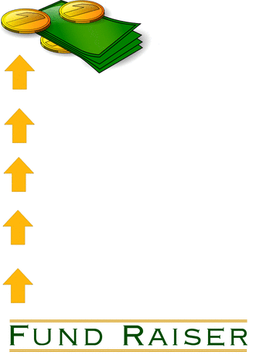
A small percentage of the proceeds will help our Post keep some of our programs running such as:

- Bingo at Clayton Senior Center
- Youth Programs –Oratorical Contest & Boy’s State
- Vet Tech – Basic Computer Training for Veterans
- Partnership with Serve the Need in Johnston County
We served our country, now we are serving our community. Please come out and support our Veterans!! | Event Info  Date: April 13, 2014  (Palm Sunday)  Time: 2:00-5:00  Phone: 919-602-5490  Email: Jmangum07@yahoo.com  Website:nclegion.org/post518

