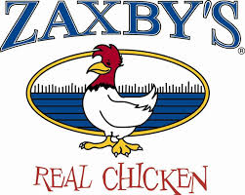

Zaxby’s Community Spirit Night
Tuesday, March 14th, 2017
5pm – 8pm
Supporting Serve The Need in Johnston County
“What We Do By Ourselves Matters: What We Do Together Really Makes The Difference”
When We Give, We Get Back

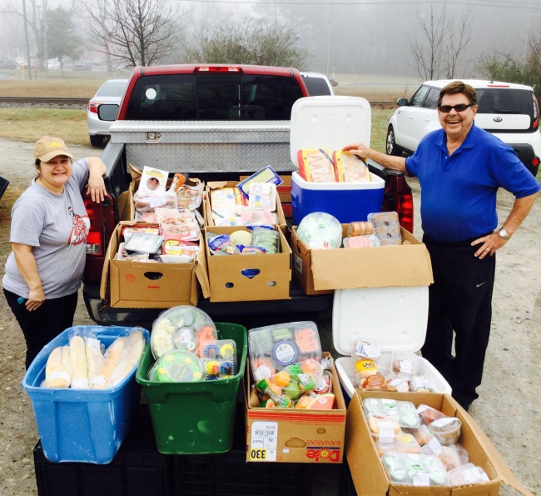

Visit www.servetheneedjc.org
STNinJC is a 501(c)3 Non-Profit Organization helping residents of Johnston County
Thank you for your support!

